DSPLogger User Guide

Version: 1.0.1
DocCode: SW-BASE-UG-0047
Date: Dec 6, 2010


www.spreadtrum.com
Important Notice
Copyright Notice
Copyright © 2007-2010, Spreadtrum Communications, Inc. All rights reserved.
Trademarks
Spreadtrum Communications, Inc. and Spreadtrum Communications, Inc.'s products are exclusively owned by Spreadtrum Communications, Inc. References to other companies and their products use trademarks owned by the respective companies and are for reference purpose only.
Warranty Disclaimer
Spreadtrum Communications, Inc. makes no representations or warranties, either expressed or implied, by or with respect to anything in this document, and shall not be liable for any implied warranties of merchantability or fitness for a particular purpose or for any indirect, special or consequential damages.
Confidentiality
The information contained herein (including any attachments) is confidential. The recipient hereby acknowledges the confidentiality of this document, and except for specific purposes, this document shall not be disclosed to any third party.
About This Document

Purpose
The DSPLogger User Guide describes the functions of DSPLogger and how to use it.

Intended Audience
This document is intended for:
- DSPLogger user

Organization
This document consists of four chapters and is organized as follows.
Chapter | Describes
1 Introduction | The functions, file compositions, and running requirements of DSPLogger.
2 Log Function | How to use the log functions.
3 Analysis Function | How to use the analysis functions.
4 File Management | How to import and export a file and introduce the file formats.

Contents
1 Introduction 1-1
1.1 Functions 1-1
1.2 File Composition 1-1
1.3 Running Requirements 1-1
2 Log Function 2-2
2.1 Settings 2-2
2.1.2 Selecting the Communication Method 2-2
2.1.3 Selecting the Data Protocol 2-3
2.1.4 Setting the Log File 2-3
2.2 Starting Logging 2-3
2.2.1 List Box 2-4
2.3 Stopping Logging 2-5
2.4 Clearing Log 2-5
2.5 Auxiliary Functions 2-5
2.5.1 Auto Scroll 2-5
2.5.2 Fasten Findding one log 2-5
2.5.3 Convert ORG to TP 2-5
3 Analysis Function 3-7
3.1 Description 3-7
3.2 Search 3-8
3.3 Mark 3-9
3.4 Chart 3-10
3.4.1 Static Analysis 3-11
3.4.2 Dynamic Analysis 3-13
3.4.3 Constellation Diagram and Channel Impulse Response Power 3-14
4 File Management 4-16
4.1 Saving a File 4-16
4.2 Importing a File 4-16
4.3 Exporting a File 4-17
4.4 File Formats 4-18
4.4.1 Log File (.tp) 4-18
4.4.2 Description File 4-18
4.4.3 Log File (.txt) 4-18
4.4.4 ORG File 4-18
4.4.5 Mark File 4-18
4.4.6 LUA File 4-18

Figures
Figure 2-1 Settings dialog box 2-2
Figure 2-2 List box 2-4
Figure 2-3 Go to specified item dialog box 2-5
Figure 2-4 Convert ORG to TP 2-6
Figure 3-1 Test point address description dialog box 3-7
Figure 3-2 Adding a description 3-8
Figure 3-3 Find Test Points dialog box 3-9
Figure 3-4 Mark dialog box 3-9
Figure 3-5 Chart window 3-10
Figure 3-6 Static graph 3-12
Figure 3-7 Dynamic graph 3-13
Figure 3-8 Constellation Diagram and Channel Impulse Response Power 3-14
Figure 4-1 Importing a file 4-16
Figure 4-2 Export Options dialog box 4-17

Tables
Table 2-1 Columns in the list box 2-4
Table 2-2 Columns in the list box 2-6
Table 3-1 Chart panel elements 3-10
Table 3-2 Chart Control box elements 3-12
Table 3-3 Dynamic graph window elements 3-13
Table 3-4 Window elements 3-14
Table 4-1 Window elements 4-16
Table 4-2 Export Options dialog box elements 4-17

Introduction

Functions
DSPLogger is used to log the DSP test point information and display the information in the form of address and data.

File Composition
DSPLogger consists of the following files:
- DspLogger.exe
- DspKernel.dll
- SciUartComm.dll
- DspLogger.dat
- CommSock.dll
- Bit.dll
- Dsp_data.lua
- Dsp_description.lua
- Dsp_keyinfo.lua
- Lua5.1.dll
- Lua51.dll
- msvcr80.dll

Running Requirements
DSPLogger runs on Windows 2000，Windows XP， VISTA， Windows7 and so on. At least one usable serial port and one network card are required.

Log Function

Settings
Click on the toolbar. The Settings dialog box is displayed, as shown in Figure 2-1. You can set the serial port parameters and the log file path in the dialog box.
              - Settings dialog box
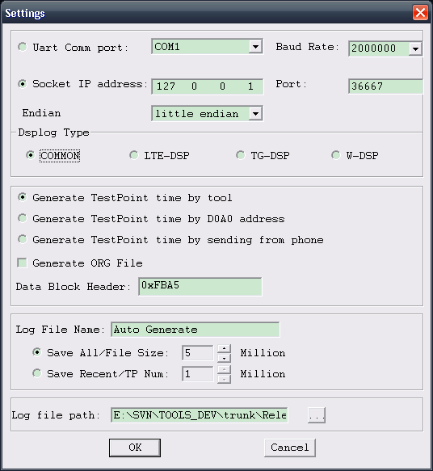

Selecting the Communication Method
- UART Comm port
Select a port in the Uart Comm port drop-down list box and then select the baud rate in the Baud Rate drop-down list box.
- Socket
Input the IP address in the Socket IP address text box and then input the port number in the Port text box.
If selected socket mode,User can set endian type and Dsplog type
- Endian
You must choose the same endian with the Phone. Now the endian option only affect socket connection. Note if you connect with ChannelServer, ChannelServer must choose
right endian.
- Dsplog type
            - COMMON :Common log,it will collect dsp log as type is 0x9D and subtype is 0x00/0x01/0x02
            - LTE-DSP: LTE log, it will collect dsp log as type is 0x9D and subtype is 0x10/0x11/0x12
            - TG-DSP: TG log, it will collect dsp log as type is 0x9D and subtype is 0x20/0x21/0x22
            - W-DSP: WCDMA log, it will collect dsp log as type is 0x9D and subtype is 0x30/0x31/0x32

Selecting the Data Protocol
- Time of TP data
The time of TP data is usually generated by DSPLogger, so < Generate TestPoint Time > item is selected by default. If the time of the TP data is transferred by MS, then do not select < Generate TestPoint Time > item.
- Storage of ORG file
If < Generate ORG File > item is selected, the ORG file will be generated by DSPLogger, otherwise, the ORG file won’t be generated.
- Frame head of data block
DSPLogger also surpports to parse one block data which is flagged by some special frame head. This fame head can be defined by user, by default, the frame head is: 0xFBA5 as shown in < Data Block Header > editbox.

Setting the Log File
          - Input the log file name in the Log File Name text box. The default setting is Auto Generate.
          - Save the test points.
- Select Save All/File Size to save all test points. Each file saves xx million test points.
- Select Save Recent/TP Num to save the recent xx million test points.
          - Input the file path in the Log file path text box.
You may also click … to select the file path in the dialog box popped out.
The default file name is the time when logging starts, namely, yyyy-mm-dd-hh-mm-ss-mmm.tp.
Note:
If the data quantity is large, the tp file size may also be large. Ensure that the disk where Log File Path is on has enough space to save the recent test points.

Starting Logging
Click . The serial port is opened.
Click to start logging. Click to suspend logging and to stop logging.

List Box
              - List box
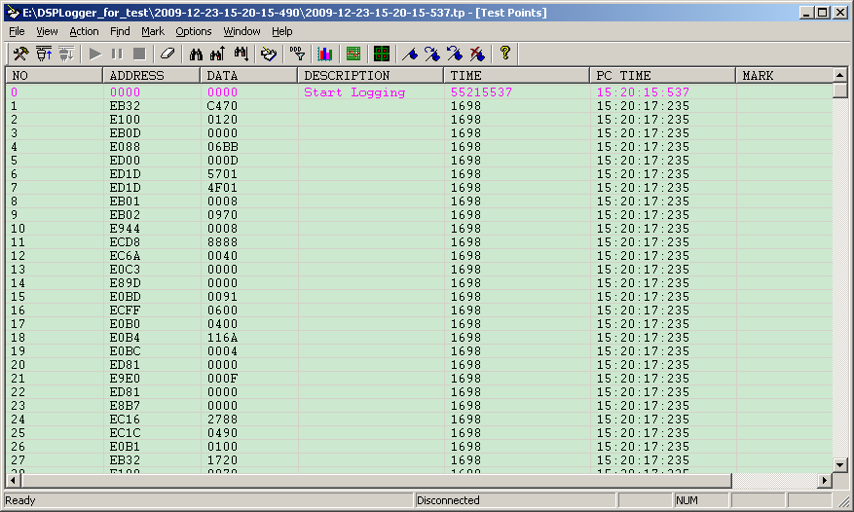

                - Columns in the list box
Column | Description
NO | Test point number
ADDRESS | Test point address
DATA | Test point data
DESCRIPTION | Test point description
TIME | Period between you click and the log is received, in units of millisecond
PC TIME | PC time, Period between you click and the log is received, in units of millisecond
MARK | Mark

Stopping Logging
Click to stop logging and to close the serial port. You can analyze the data that received form serial port before.

Clearing Log
Click to clear all the current logs.
Note:
The current logs are cleared when you open the serial port again.

Auxiliary Functions

Auto Scroll
By default, the last log is always visible. To view a specific log, click this log in the list and clear the AutoScroll check box in the dialog box popped out.

Fasten Findding one log
To quickly find a log, you can right-click the list. The Go to specified item dialog box is displayed, as shown in Figure 2-1. Input the index and click OK.
              - Go to specified item dialog box
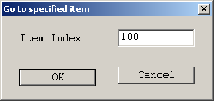

Convert ORG to TP
If you want to convert ORG file to TP file, you can click [File]->[Convert Org…] to open the dialog box shown as follow:
              - Convert ORG to TP
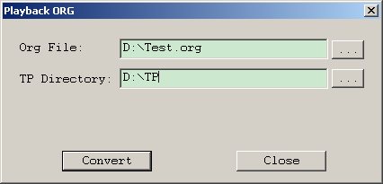
                - Columns in the list box
Column | Description
Org File | The path of ORG file
TP Directory | The path of TP file. The name of TP file is generated by DSPLogger, the user only need to select the directory
Convert | Start to convert
Close | Close the dialog box

Analysis Function

Description
Click, the Test point address description dialog box is displayed, as shown in Figure 3-1.
              - Test point address description dialog box
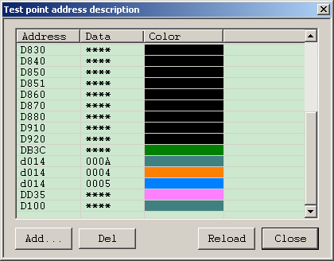

The list box in the Test point address description dialog box has the following columns:
- Address: log address
- Data: log data
- Color: log color
If the address of an item is the same as that in the list, it will be displayed with the color that described in the list.

Adding a Color
Click Add…. The Edit address color dialog box is displayed, as shown in Figure 3-1. The Filter text box is currently disable.
              - Adding a description
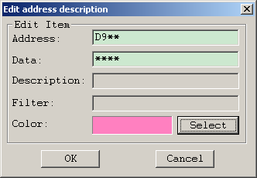
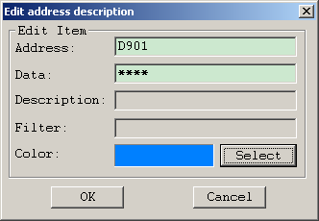

Deleting a Color
Select the log to be deleted and click Del or press Delete.

Saving Color
After being modified, all the colors are automatically saved in DspLogger.dat.

Reloading Color
Click Reload. The colors last saved are restored and all the modifications that are not saved are lost.

Search
Click . The Find Test Points dialog box is displayed, as shown in Figure 3-1.
              - Find Test Points dialog box
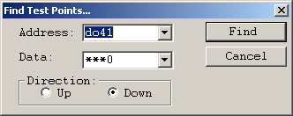

          - Input the address in the Address box and data in the Data box.
          - Select the direction in the Direction area.
          - Click Find.
The search starts from the current log. If no log is selected, the search starts from the first log.
Note:
- To search by address, do not fill in the Data box. To search by data, do not fill in the Address box.
- You can select the data input previously in the Address and the Data boxes.
- You can use * that indicates any character for fuzzy search. For example, Input 2*00 and you can find 2000 and 2100 and so on.
- In the log list, press F6 to search upwards and press F5 to search downwards.

Mark
You can mark the records.
Select a log and click . The Mark dialog box is displayed, as shown in Figure 3-1.
              - Mark dialog box
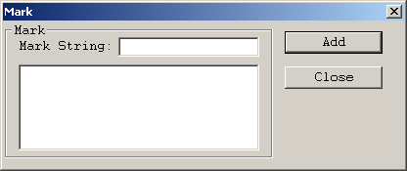

Input the mark string in the Mark String text box and click Add. The Mark column will display the character string.
Click and to traverse the marks in the same group.
Select the marked item and click . The selected item is unmarked.
Click to clear all the marks.
All the marks are lost after you quit the program.

Chart
DSPLogger supports displaying the logs in charts.
Click . The Chart window is displayed, as shown in Figure 3-1.
              - Chart window
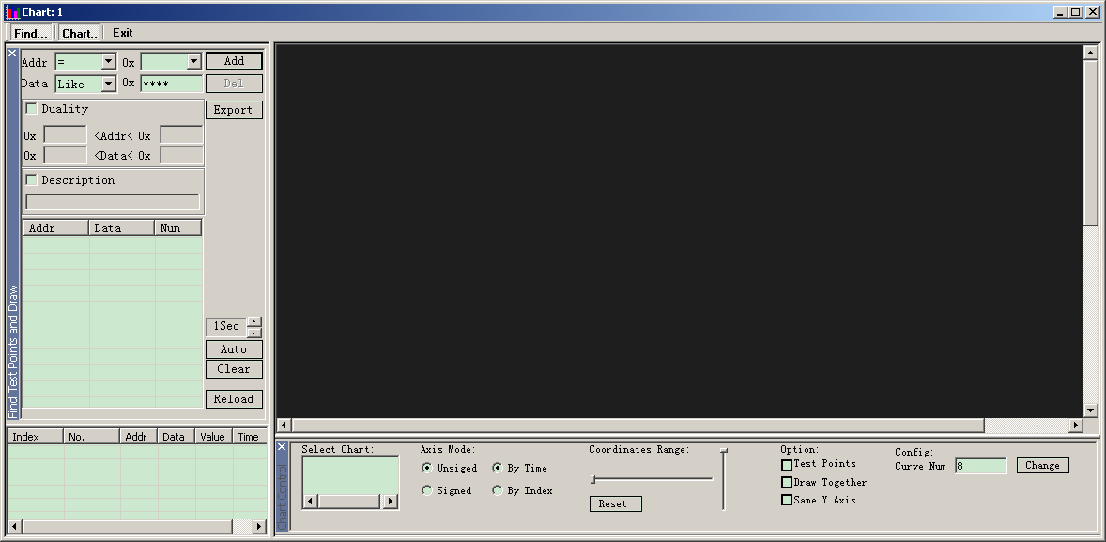

                - Chart panel elements
Element | Description
Addr box | Address
Data box | Data
Duality | Supporting compare more parameters, such as: A<value<B
Description | Searching test point by description
Add button | Add a search condition
Del button | Delete a search condition
Export button | Export the searched data
Auto button | Update the interval
Clear button | Clear the graph and data
Reload button | Reload the graph an data
Find Test Points and Draw list box | Consists of the Addr, Data, and Num columns
Test point information list box | Consists of the Index, No, Address, Data, and Time columns
Graph area | Displays the test points graph
Chart Control box | Set the parameters of the graph

After setting the search conditions, start searching. The search results are displayed in the test point information list box and the graph area.
- The No column indicates the location of the test point in the list. The other columns are the same as that in the Find Text Points and Draw list box.
- In the graph area, the x axis is the time or index, and the Y axis is the data.
Click the graph,
- The point closest to the pointer is selected, displayed in white cross.
- The item corresponding to the point is selected in the test point information list box.
Double-click an item in the test point information list box, the corresponding point is selected in the graph.

Static Analysis

Static Graph
The test points graph intuitively reflects the changes of data, as shown in Figure 3-1
              - Static graph
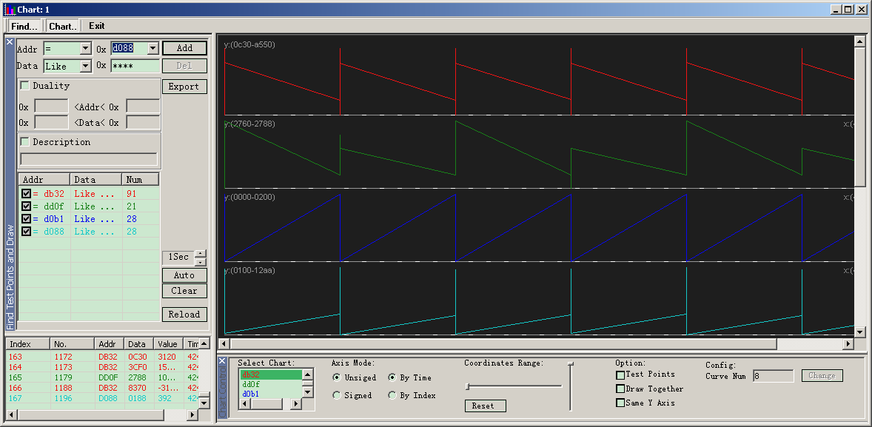

Chart Control
                - Chart Control box elements
Element |  | Description
Select Chart text box | - | Select the chart to be adjusted
Axis Mode field | Unsigned and Signed options | Display unsigned or signed integers
Axis Mode field | By Index and By Time options | Use index or time as the horizontal axis
Coordinates Range slide bar | Horizontal bar | Horizontal zoom
Coordinates Range slide bar | Vertical bar | Vertical zoom
Coordinates Range slide bar | Reset button | Reset the graph data
Option field | Test Points check box | Whether draw the test points in the graph
Option field | Draw Together check box | Whether to draw multiple sub charts in one coordinate system
Option field | Unified Y Axis check box | Whether multiple sub charts use the same Y axis
Config Curve Num text box | - | There are four curves by default. The maximum number is 20.  Input the number before adding any curves in the Curve Num text box and then click Change.

Dynamic Analysis
The data can be displayed in real time, as shown in Figure 3-1.
              - Dynamic graph
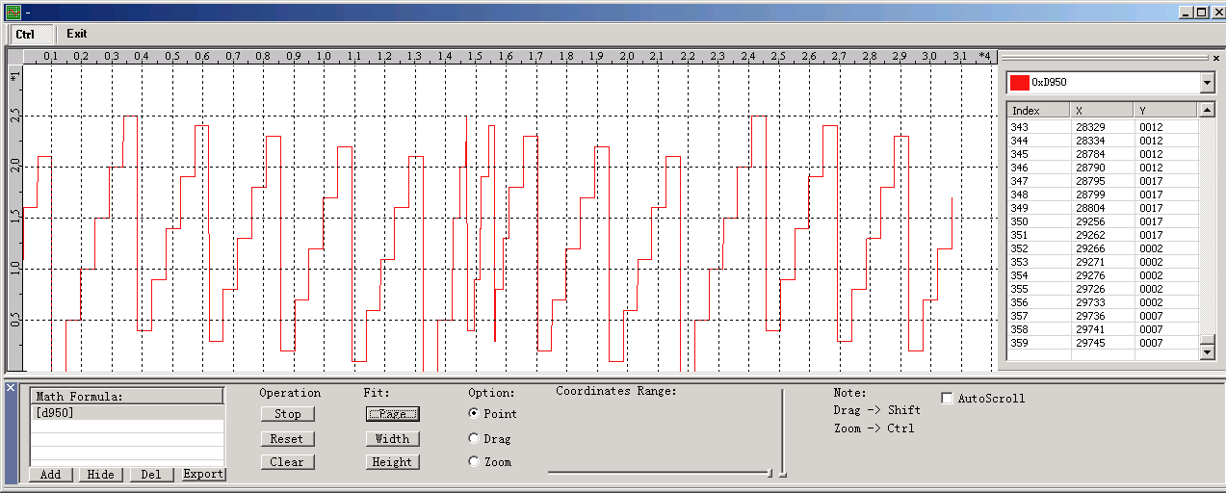

                - Dynamic graph window elements
Element |  | Description
Add button | - | Add a formula
Hide button | - | Hide the selected graph
Del button | - | Delete the selected graph
Export button | - | Export the data of the selected graph
Operation field | Start/Stop button | Start/ stop updating the graph
Operation field | Reset button | Reset the graph data
Operation field | Clear button | Clear the graph data
Fit field | Page button | Display the graph by the current coordinate system
Fit field | Width button | Display the graph by the current coordinate width
Fit field | Height button | Display the graph by the current coordinate height
Option field | Point option | Select points
Option field | Drag option | Drag the graph
Option field | Zoom option | Zoom the graph
Coordinates Range slide bar | Horizontal bar | Horizontal magnification
Coordinates Range slide bar | Vertical bar | Vertical magnification

Constellation Diagram and Channel Impulse Response Power
DSPLogger also surpports to display constellation diagram and channel impulse response power automatically. The dialog box is shown as follow:
              - Constellation Diagram and Channel Impulse Response Power
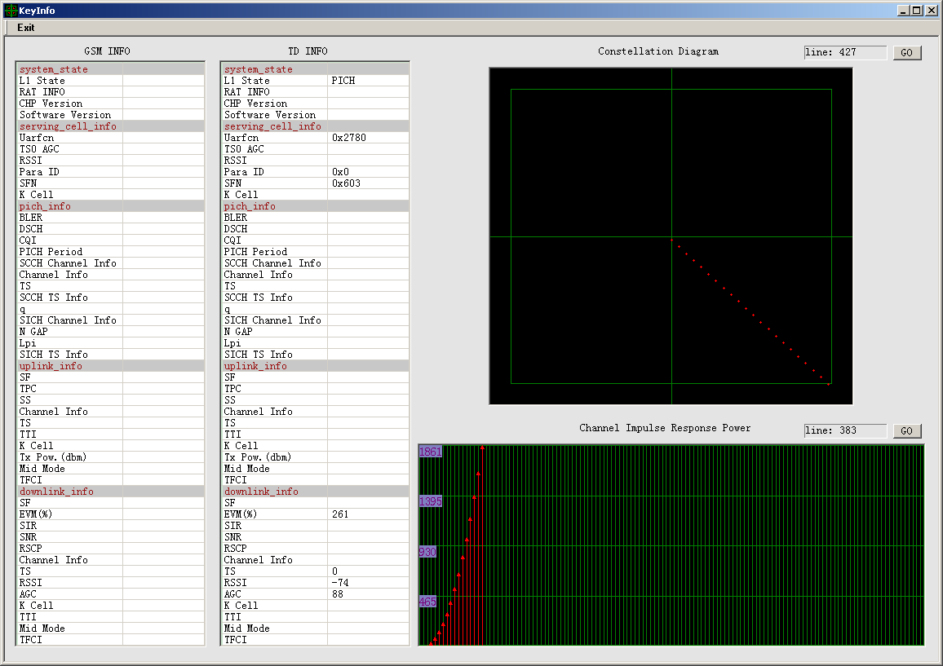
                - Window elements
Element |  | Description
GSM INFO | - | Information of GSM. You can change these by edit dsp_keyinfo.lua.lua
TD INFO | - | Information of TD. You can change these by edit dsp_keyinfo.lua.lua
Line |  | The line number of the first data of the constellation diagram which corresponding to the main interface
GO button |  | Click this button, it will be jumped to the same line in the main interface
The items that in the dialog box will be updated dynamically when receive the data from the phone. Constellation diagram and channel impulse response power only display the latest data, the historical data will not be saved.
When playing back TP file, double click some one item that in the main interface, DSPLogger will search the latest data about constellation diagram and channel impulse response power and then display in the < Constellation Diagram and Channel Impulse Response Power > dialog box.

File Management

Saving a File
DSPLogger generates the TP file stored in the path that the user input in the <Setting> dialog box. In order to easily save and parse TP data, the files that generated in one Start-Stop will be saved in the same directory. By default, the directory will be named by local time. When needing to save as files, there are three modes to select, “All”, “Recently two files”, “Current file”. If you select “All”, DSPLogger will save as the directory to the specified path.

Importing a File
Choose File > Import…. Select the file to be imported in the dialog box popped out.
The dialog box is shown as bellow:
              - Importing a file
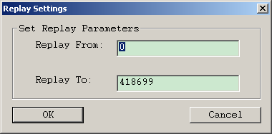
                - Window elements
Element | Description
Replay From | The first item of the playing back  By default, it replays from 0
Replay To | The last item of the playing back  By default, it replays to the max item

Exporting a File
The log file (*.tp) is a binary file not convenient to view and analyze, so DSPLogger surpports two mode to convert it.
Log: Converting the TP file to a text file.
Org: Converting the TP file to a binary file with the original data.
Choose File > Export…. The Export Options dialog box is displayed, as shown in Figure 4-1.
              - Export Options dialog box
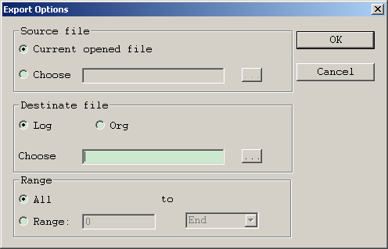

                - Export Options dialog box elements
Element | Description
Source file area | Path of the file to be converted
Destinate file area | Path and mode of the file that is converted. ”Log” is text mode, and “Org” is binary mode
Range area | Range of the items to be converted in the log file

File Formats

Log File (.tp)
The log file (.tp) is a binary file.
Each log has 8 bytes.
- The first two bytes saves the address.
- The subsequent two bytes saves the data in BigEndian.
- The last four bytes saves the time and is in LittleEndian.

Description File
The description file (DspLogger.dat) saves all the log descriptions. It is a text file and can be manually modified.
Each line in the file is a log description consisting of the log address and the description character string that are separated by a blank.

Log File (.txt)
The log file (.txt) is converted from the binary log file. For details, refer to section 4.3 .
Each line in the file is a log consisting of the log address, data, and the range that are separated by blanks.

ORG File
ORG file saves the original data which is received from the UART. Its content is some binary stream. This file can be converted to TP file.

Mark File
Mark file is a binary file which is corresponding to TP file. When the user marked some test point in the main interface, then the mark file will be generated with the same name as the TP file but used the .mark as the extend name. If there is some one mark file in the directory corresponding with the TP file, when this TP file is played back, the mark file also can be loaded to display in the “Mark” item.
The format of this file is: TP index (4 bytes), Mark content length (4 bytes), and mark content.

LUA File
There are three lua file used in DSPLogger: dsp_data.lua, dsp_description.lua, and dsp_keyinfo.lua.
dsp_data.lua: used to calculate data vale.
dsp_description.lua: used to describe some one test point
dsp_keyinfo.lua: used to display constellation diagram and channel impulse response power
These files can be edited by user.

